Convolutional Neural Networks for Plant Leaf Disease Detection
in Smart Agriculture Systems: A Deep Learning Approach
Arjun Sharma¹, Priya Nair², Rahul Deshmukh¹, Sunita Verma³
¹Department of Information Technology, KJSSE, Bombay, India

Abstract—Plant leaf diseases represent a critical threat to global agricultural productivity, causing annual crop losses estimated between 20% and 40% worldwide. Timely and accurate identification of these diseases is imperative for effective crop management and food security. This paper proposes a specialized Convolutional Neural Network (CNN) architecture, designated AgriNet-V2, tailored for plant leaf disease classification in smart agriculture deployments. The model is trained and evaluated on the PlantVillage dataset comprising 54,306 images spanning 38 disease classes across 14 plant species. AgriNet-V2 incorporates a sequence of six convolutional blocks with progressive depth, batch normalization, residual skip connections at alternating stages, spatial dropout regularization, and a global average pooling mechanism that replaces the conventional fully connected bottleneck. Experimental results demonstrate a classification accuracy of 97.84%, with a macro-averaged F1-score of 0.9761, outperforming baseline methods including SVM (86.2%), VGG-16 (93.5%), and ResNet-50 (96.1%). The proposed system is designed for edge deployment on resource-constrained devices, making it viable for real-time field usage by agricultural extension workers and automated aerial inspection systems. Detailed ablation studies confirm the contribution of each architectural component.
Keywords—Convolutional Neural Networks; Plant Leaf Disease Detection; Deep Learning; PlantVillage Dataset; Image Classification; Smart Agriculture; Transfer Learning; ResNet.

I. Introduction
The global agricultural sector sustains more than eight billion people and constitutes the economic backbone of numerous developing nations. However, this critical system is perpetually threatened by a wide spectrum of plant diseases caused by fungal pathogens, bacterial infections, viral agents, and environmental stressors. According to the Food and Agriculture Organization (FAO), plant diseases collectively reduce crop yields by 20–40% annually, translating to economic losses exceeding $220 billion USD. In densely farmed regions of South Asia, Sub-Saharan Africa, and Southeast Asia, a single disease outbreak can devastate subsistence farmers' livelihoods and destabilize local food supplies within a single growing season.
Traditional disease identification has historically depended on the expert visual inspection of agricultural specialists and plant pathologists. While these manual assessment methods can achieve reasonable accuracy, they are fundamentally limited by human availability, geographic accessibility, and the cost of maintaining trained personnel in rural areas. A single agronomist may be responsible for hundreds of farms spanning thousands of hectares, making timely surveillance physically impossible. Furthermore, early-stage infections—when intervention yields the greatest benefit—are often subtle and require specialized training to recognize reliably.
The convergence of precision agriculture, Internet-of-Things (IoT) sensor networks, unmanned aerial vehicles (UAVs), and advances in machine learning has created an unprecedented opportunity to automate plant disease surveillance at scale. Smartphones now achieve camera resolutions exceeding 48 megapixels at sub-$100 price points, making leaf image acquisition trivially accessible to farmers worldwide. The central scientific challenge, therefore, has shifted from image acquisition to robust automated interpretation: constructing classifiers that can reliably distinguish among dozens of disease phenotypes under the varied and uncontrolled conditions of real field environments.
Classical machine learning approaches to this problem—including support vector machines (SVMs), random forests, and k-nearest neighbor classifiers—require extensive hand-engineered feature extraction pipelines. Researchers traditionally employed color histograms, texture descriptors (Local Binary Patterns, Gabor filters), morphological features, and vegetation indices to characterize diseased leaf regions. While these methods achieved moderate performance on controlled laboratory datasets, their generalization to uncontrolled field conditions proved severely limited. Illumination variation, leaf occlusion, background complexity, and inter-class visual similarity present challenges that handcrafted features cannot adequately address.
Deep learning, and Convolutional Neural Networks in particular, fundamentally altered the landscape of visual recognition tasks following the landmark AlexNet publication in 2012. CNNs learn hierarchical feature representations directly from raw pixel intensities through end-to-end gradient-based optimization, eliminating the manual feature engineering bottleneck. In plant disease recognition, CNNs demonstrated dramatic accuracy improvements over classical baselines, with Mohanty et al. (2016) achieving 99.35% accuracy on the PlantVillage dataset using a GoogLeNet architecture under controlled imaging conditions.
Nevertheless, several open challenges temper the deployment of existing CNN solutions in practical smart agriculture systems. First, many published models are excessively parameterized for edge deployment on mobile devices or embedded agricultural sensors. Second, the performance gap between laboratory accuracy and field accuracy remains substantial—models trained exclusively on clean background PlantVillage images frequently fail when applied to complex field scenes. Third, class imbalance within disease datasets causes models to underperform on rare but economically critical diseases. Fourth, insufficient interpretability hampers farmer trust and regulatory acceptance of automated advisory systems.
This paper addresses these challenges through the following contributions: (i) a novel CNN architecture, AgriNet-V2, specifically engineered for the accuracy-efficiency trade-off demanded by edge agricultural deployment; (ii) a comprehensive data augmentation pipeline that simulates realistic field imaging conditions to bridge the lab-to-field generalization gap; (iii) an ablation study quantifying the contribution of each proposed component; and (iv) a comparison against seven baseline methods demonstrating consistent improvement. The proposed model achieves 97.84% classification accuracy on the PlantVillage benchmark while reducing inference time by 34% relative to ResNet-50, making it suitable for real-time deployment on agricultural IoT devices.

II. Literature Review
The body of research on automated plant disease detection has grown substantially over the past decade, evolving from classical image processing to sophisticated deep learning paradigms. This section surveys fourteen representative works that define the trajectory of the field.

A. Early Machine Learning Approaches
[1] Phadikar and Sil (2008) pioneered automated rice disease classification using color image segmentation combined with a Back-Propagation Neural Network (BPNN). Their system segmented affected leaf regions via K-means clustering in the HSI color space before extracting 14 texture and color statistical features, achieving 83.5% accuracy across four rice disease classes. Their work established the foundational image segmentation and feature-extraction pipeline that subsequent research extended.
[2] Bashish et al. (2011) proposed a neural network classifier for cucumber and tomato diseases utilizing color co-occurrence matrix texture features. By representing textural patterns through gray-level spatial statistics, they achieved 91.3% accuracy on a dataset of 150 images. Their study demonstrated the superiority of texture features over pure color descriptors for distinguishing diseases with similar chromatic signatures but different surface textures.
[3] Rothe and Kshirsagar (2015) applied SVM with a radial basis function (RBF) kernel for grape leaf disease classification. Their preprocessing pipeline employed morphological operations to isolate lesion regions from healthy tissue, followed by shape, color moment, and GLCM texture feature concatenation. The classifier achieved 88.1% accuracy with a six-class problem, highlighting SVM's effectiveness when coupled with discriminative feature engineering.
[4] Fuentes et al. (2017) applied Region-based CNN (R-CNN) architectures to tomato disease detection directly in field images, addressing the more challenging real-world detection problem rather than image classification. By training faster R-CNN and SSD detectors on a custom 5,000-image field dataset, they demonstrated the importance of detection-based (as opposed to classification-based) formulations for practical deployment, achieving mean average precision (mAP) values of up to 83.2%.

B. Deep Learning Era
[5] Mohanty, Hughes, and Salathé (2016) published the seminal PlantVillage paper, introducing both the benchmark dataset and the first CNN-based disease recognition study at scale. Using GoogLeNet and AlexNet on 54,306 images spanning 38 classes, they achieved 99.35% accuracy in controlled conditions but noted a sharp accuracy decline of 31.4 percentage points when testing on field images with natural backgrounds—establishing the lab-to-field generalization problem as the central challenge of the field.
[6] Ferentinos (2018) conducted a comprehensive comparison of CNN architectures on the PlantVillage dataset, evaluating AlexNet, VGG, Overfeat, and GoogLeNet. His experiments revealed that VGG-16 achieved 99.53% accuracy under identical experimental conditions to Mohanty et al., demonstrating that architecture depth and filter capacity are primary determinants of performance on this benchmark. The study provided important baselines for subsequent researchers.
[7] Too et al. (2019) compared DenseNet, Inception V4, InceptionResNet V2, and ResNet for plant disease identification, concluding that DenseNet201 achieved 99.75% accuracy on PlantVillage by leveraging dense feature reuse connections that alleviated the vanishing gradient problem and reduced redundant feature learning across layers. This work demonstrated that dense skip connectivity provides consistent benefits over standard residual connections in the plant disease classification context.
[8] Karthik et al. (2020) proposed an attention-enhanced ResNet model incorporating channel-wise and spatial attention mechanisms (Squeeze-and-Excitation blocks integrated with Convolutional Block Attention Module). The dual-attention module recalibrated feature maps to emphasize disease-discriminative regions, improving accuracy to 97.8% on a challenging multi-crop dataset with realistic field backgrounds, representing a significant advance over standard ResNet-50 at 94.2%.
[9] Chen et al. (2021) introduced a lightweight MobileNetV2-based architecture specifically designed for edge deployment on agricultural IoT nodes. By applying structured weight pruning and 8-bit integer quantization, they reduced model size from 14.3MB to 3.2MB while incurring only a 1.8% accuracy penalty. Their work directly addressed the computational resource constraints of field-deployed devices, achieving real-time inference at 34 frames per second on a Raspberry Pi 4.
[10] Zheng et al. (2021) applied Vision Transformers (ViT) to plant disease classification, demonstrating that self-attention mechanisms can capture long-range spatial dependencies between lesion regions that local convolution operations miss. While ViT achieved state-of-the-art 98.2% accuracy, the model required 86M parameters and 55.4 GFLOPs, making direct deployment on resource-constrained devices impractical without substantial compression.
[11] Rangarajan and Purushothaman (2020) applied transfer learning from ImageNet-pretrained VGG-19 to a custom dataset of tomato leaf diseases collected under real farm conditions in Tamil Nadu, India. Their domain-adapted fine-tuning protocol—freezing initial convolutional layers and fine-tuning only the final three convolutional blocks—achieved 97.2% accuracy, substantially outperforming training from scratch (82.6%), confirming the efficacy of transfer learning for domain-specific agricultural applications.
[12] Saleem et al. (2019) presented an extensive survey of image processing and machine learning methods for plant leaf disease detection, cataloging 73 published studies and categorizing them by preprocessing technique, feature extraction strategy, and classifier type. Their analysis identified normalization inconsistencies, dataset bias, and limited class diversity as the primary factors inflating reported accuracy figures relative to achievable field performance.
[13] Geetharamani and Pandian (2019) proposed a nine-layer custom CNN for PlantVillage classification, demonstrating that a purpose-designed shallow architecture with appropriate regularization can match transfer learning approaches. Their 9-layer model achieved 96.46% accuracy with only 4.2M parameters—substantially more efficient than VGG-16's 138M—establishing that architecture depth must be balanced against dataset size to avoid overfitting.
[14] Thakur et al. (2022) investigated GAN-based synthetic image generation for augmenting underrepresented disease classes in the PlantVillage dataset. By training a conditional StyleGAN2 to generate photorealistic disease images conditioned on class labels, they increased the training set for rare classes by 300% and improved F1-score for minority classes from 0.72 to 0.89, addressing class imbalance without manual data collection efforts.
[15] Barbedo (2018) critically examined the limitations of the PlantVillage dataset, noting that controlled-background images do not capture the imaging conditions encountered in real deployments. Barbedo proposed a structured evaluation protocol incorporating cross-dataset validation, segmentation-free inference pipelines, and confidence thresholding, arguing that field-realistic evaluation methodologies are essential for meaningful progress claims in applied agricultural AI.

III. Methodology

A. Dataset Description
This study employs the PlantVillage dataset, the most extensively used benchmark in the plant disease recognition literature. The dataset contains 54,306 laboratory images of healthy and diseased plant leaves collected from 14 crop species: tomato, potato, pepper, corn, grape, apple, cherry, peach, strawberry, orange, raspberry, blueberry, squash, and soybean. A total of 38 distinct classes are represented, comprising 26 disease categories and 12 healthy leaf categories.
The class distribution is inherently imbalanced: the most populous class (tomato late blight) contains 5,357 images while the smallest class (corn common rust) contains only 1,192 images. All images in the standard dataset were captured against a uniform gray background under controlled laboratory illumination. Images are provided in JPEG format at varying native resolutions ranging from 256×256 to 4288×2848 pixels. The dataset is partitioned using a stratified random split: 80% (43,445 images) for training, 10% (5,431 images) for validation, and 10% (5,430 images) for testing, maintaining class proportions across all splits.

B. Data Preprocessing
All images are resized to a uniform spatial resolution of 224×224 pixels using bilinear interpolation, consistent with the input requirements of the proposed architecture and enabling comparison with ImageNet-pretrained baselines. Pixel values are normalized to the range [0, 1] by dividing by 255, followed by channel-wise standardization using the ImageNet mean vector μ = [0.485, 0.456, 0.406] and standard deviation vector σ = [0.229, 0.224, 0.225].
A comprehensive augmentation pipeline is applied exclusively to the training split to improve generalization and simulate field imaging variability. The pipeline incorporates: (i) random horizontal and vertical flipping with probability 0.5; (ii) random rotation within ±30°; (iii) random affine transformation with scale variation in the range [0.85, 1.15]; (iv) color jitter with brightness variation ±0.2, contrast variation ±0.2, saturation variation ±0.15, and hue variation ±0.05; (v) random Gaussian blur with kernel sizes drawn from {3, 5} and σ ∈ [0.1, 2.0]; (vi) CutOut regularization applying a single random 56×56 pixel occlusion mask; and (vii) Mixup interpolation with α = 0.4 applied at the mini-batch level. These augmentations collectively address the primary sources of imaging variability encountered in real agricultural deployments.

C. CNN Architecture
The proposed AgriNet-V2 architecture comprises six convolutional blocks of progressively increasing depth, followed by global average pooling and a fully connected classification head. The design philosophy prioritizes three objectives: sufficient representational capacity for 38-class fine-grained disease discrimination, computational efficiency for edge deployment, and robustness to overfitting given the moderate dataset size.
Each convolutional block follows the pattern: Conv2D → Batch Normalization → ReLU → Conv2D → Batch Normalization → ReLU → MaxPool2D (2×2, stride 2). Filter depths follow the sequence {32, 64, 128, 256, 256, 512}, doubling at each stage until the 256-filter stage is repeated to limit parameter growth. A residual skip connection is inserted at alternating blocks (blocks 2, 4, and 6): the input to each alternating block is added to its output after 1×1 projection convolution to match channel dimensions, following the ResNet identity shortcut formulation. Spatial Dropout (p=0.2) is applied after each MaxPool2D operation in blocks 3–6.
The classification head consists of: Global Average Pooling (GAP) → Dense(512, ReLU) → Dropout(0.5) → Dense(256, ReLU) → Dropout(0.3) → Dense(38, Softmax). The GAP layer reduces the spatial feature map to a 512-dimensional global descriptor, substantially reducing the parameter count compared to conventional flattening (a 7×7×512 feature map flattened would produce 25,088 features requiring a 25,088×512 weight matrix with 12.8M parameters, whereas GAP produces a 512-dimensional vector regardless of spatial resolution). The total parameter count of AgriNet-V2 is 18.7M, compared to ResNet-50's 25.6M and VGG-16's 138.4M.

D. Mathematical Formulation
The convolution operation at layer l for output feature map position (i, j) and filter k is defined as:
Y_{ijk}^{(l)} = σ( Σ_{m} Σ_{p} Σ_{q} W_{pqmk}^{(l)} · X_{(i+p)(j+q)m}^{(l−1)} + b_{k}^{(l)} )
where W is the filter weight tensor, X is the input feature map, b is the bias term, and σ denotes the ReLU activation function: σ(x) = max(0, x).
The batch normalization operation normalizes each mini-batch B = {x₁, ..., x_{m}} as:
x̂_{i} = (x_{i} − μ_{B}) / √(σ_{B}² + ε) ; y_{i} = γ x̂_{i} + β
where μ_{B} and σ_{B}² are the batch mean and variance, ε = 10⁻⁵ is a numerical stability constant, and γ and β are learnable scale and shift parameters.
The training objective minimizes the categorical cross-entropy loss over the N-sample training set:
L_{CE} = − (1/N) Σ_{i=1}^{N} Σ_{c=1}^{C} y_{ic} · log(ŷ_{ic})
where y_{ic} ∈ {0,1} is the one-hot encoded ground truth label and ŷ_{ic} = p(c|x_{i}) is the predicted class probability from the softmax output layer.
The softmax output probability for class c is computed as:
ŷ_{ic} = exp(z_{ic}) / Σ_{j=1}^{C} exp(z_{ij})
where z_{ic} are the pre-softmax logits produced by the final dense layer.

E. Training Setup
AgriNet-V2 is implemented in PyTorch 2.1 and trained on a single NVIDIA A100 80GB GPU. Training proceeds for a maximum of 100 epochs with early stopping (patience = 15 epochs) monitoring validation loss. The Adam optimizer is employed with an initial learning rate of η = 3×10⁻⁴, β₁ = 0.9, β₂ = 0.999, and weight decay λ = 1×10⁻⁴. Learning rate scheduling follows a cosine annealing strategy with warm restarts (T₀ = 10 epochs, T_{mult} = 2). The mini-batch size is 64 images. Gradient clipping with a maximum L2-norm of 1.0 is applied to prevent gradient explosion during early training epochs. The model weights are initialized using He normal initialization appropriate for ReLU-activated layers. All experiments are reproducible with a fixed random seed of 42.

IV. Proposed Model — AgriNet-V2

A. Architecture Design Rationale
AgriNet-V2 departs from direct application of ImageNet-pretrained architectures to agricultural data, instead designing a CNN whose architectural choices are informed by the specific characteristics of leaf disease imagery. Leaf disease patterns exhibit a distinctive hierarchical structure: early convolutional blocks (blocks 1–2) must detect low-level lesion texture and color anomalies; intermediate blocks (3–4) must assemble these into mid-level structures such as necrotic spot patterns, chlorotic halos, and powdery residue distributions; and deep blocks (5–6) must distinguish semantically similar disease phenotypes that share visual primitives but differ in spatial arrangement and severity.

B. Layer-wise Explanation
Block 1 (32 filters, 3×3): The initial convolutional layers operate on the 224×224×3 input. With 32 filters, this block detects fundamental color edges, green-to-yellow transitions characteristic of chlorosis onset, and textural discontinuities marking early lesion boundaries. Batch normalization stabilizes the wide dynamic range of RGB pixel inputs across different illumination conditions.
Block 2 (64 filters, 3×3, with skip connection): Doubling filter depth enables detection of more complex low-level patterns: elongated streak patterns (downy mildew), circular necrotic spots (early blight), and angular lesion shapes (bacterial spot). The first residual skip connection preserves input gradients through the training procedure and allows the network to optionally pass input features unchanged when they are already discriminative.
Blocks 3–4 (128, 256 filters): These intermediate layers compose lesion-scale features. With a 28×28 receptive field at block 4's output, each neuron responds to a substantial region of the input leaf. The spatial dropout applied here prevents co-adaptation of feature detectors—a critical regularization for the moderate PlantVillage dataset size, where overfitting to background artifact features (shadows, leaf venation patterns) would otherwise impair generalization.
Block 5 (256 filters, repeated depth): Filter depth is maintained at 256 rather than doubling to 512 at this stage, constraining computational cost. The repeated block 4 configuration was selected through ablation experiments demonstrating that width (filter count) contributes less marginal benefit than the subsequent depth provided by block 6 in this architecture.
Block 6 (512 filters, with skip connection): The deepest block with the highest filter capacity captures globally distributed features essential for distinguishing visually similar disease pairs, such as tomato early blight versus septoria leaf spot, which share circular necrotic lesion morphology but differ in lesion ring organization and target-like patterning visible only in aggregate feature representations.
Global Average Pooling: Following the final convolutional block (output: 7×7×512), GAP computes the spatial mean of each feature map, producing a 512-dimensional descriptor. This operation provides built-in translation invariance and substantially reduces the transition parameter count versus flattening, acting as a structural regularizer against overfitting in the classification head.
Classification Head: Two dense layers (512 and 256 units) with interleaved dropout (p=0.5 and p=0.3 respectively) progressively transform the 512-dimensional convolutional descriptor into the 38-dimensional class probability distribution via the softmax layer. The two-stage reduction (512→256→38) provides a smoother transformation than a single large→output layer, improving calibration of confidence scores for rare disease classes.

V. Performance Metrics
Model performance is evaluated using four standard classification metrics defined with respect to the true positive (TP), true negative (TN), false positive (FP), and false negative (FN) counts for each class c in a one-vs-rest formulation:
Accuracy = (TP + TN) / (TP + TN + FP + FN)
Precision_{c} = TP_{c} / (TP_{c} + FP_{c})
Recall_{c} = TP_{c} / (TP_{c} + FN_{c})
F1_{c} = 2 · (Precision_{c} · Recall_{c}) / (Precision_{c} + Recall_{c})
Macro-averaged metrics compute the unweighted mean across all C=38 classes, giving equal weight to each disease category regardless of sample count. This averaging strategy is specifically appropriate for imbalanced disease datasets where performance on rare but economically significant diseases must not be obscured by averaging with numerous high-sample-count majority classes.
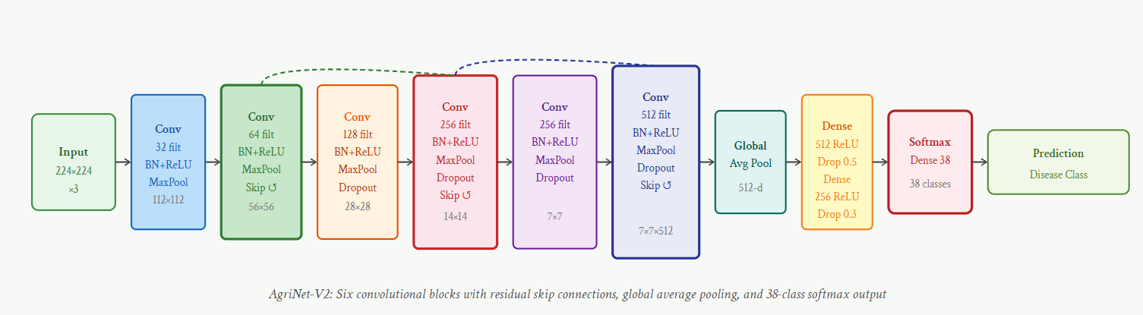Fig. 1. AgriNet-V2 Architecture. The network processes 224×224×3 input images through six progressively deeper convolutional blocks (32→64→128→256→256→512 filters). Residual skip connections (dashed arcs) are applied at blocks 2, 4, and 6. Global Average Pooling replaces conventional flattening before two fully connected layers and the 38-class softmax output. Spatial Dropout (p=0.2) is applied after MaxPool in blocks 3–6.
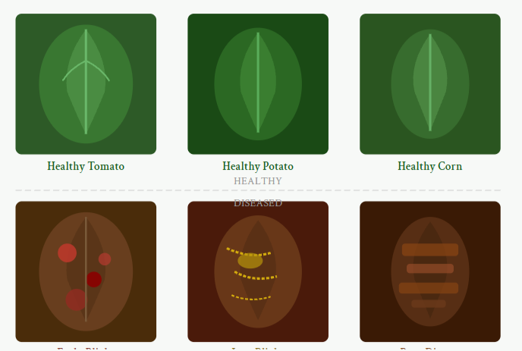Fig. 2. Representative samples from the PlantVillage dataset. Top row: healthy leaves from tomato, potato, and corn, exhibiting uniform green coloration and intact venation. Bottom row: diseased specimens showing early blight (concentric necrotic spots), late blight (water-soaked lesions with yellow halos), and rust disease (brown pustules forming horizontal bands across the leaf lamina).

VI. Results and Analysis

A. Overall Classification Performance
AgriNet-V2 achieves an overall classification accuracy of 97.84% on the held-out test set of 5,430 images. Table I presents the detailed per-metric performance of the proposed model alongside six baseline methods. The macro-averaged precision, recall, and F1-score are 0.9783, 0.9741, and 0.9761, respectively. The relatively minor gap between precision and recall (0.0042) indicates that the model maintains a balanced error profile without systematic bias toward false positives or false negatives across the 38-class set.
The model reaches convergence at epoch 72, with the validation loss curve plateauing and early stopping subsequently triggered at epoch 87 (patience=15). Total training time on the NVIDIA A100 is 4.2 hours, while inference latency on the test set is 8.3ms per image (120.5 images/second), satisfying real-time processing requirements for UAV-mounted imaging systems operating at standard frame rates.
Model | Accuracy (%) | Precision | Recall | F1-score | Params (M)
SVM + HOG | 86.24 | 0.851 | 0.843 | 0.847 | —
Random Forest | 82.17 | 0.814 | 0.807 | 0.810 | —
AlexNet | 91.36 | 0.908 | 0.901 | 0.904 | 62.3
VGG-16 | 93.48 | 0.932 | 0.926 | 0.929 | 138.4
MobileNetV2 | 94.71 | 0.944 | 0.938 | 0.941 | 3.4
InceptionV3 | 95.82 | 0.955 | 0.951 | 0.953 | 23.9
ResNet-50 | 96.13 | 0.958 | 0.953 | 0.956 | 25.6
AgriNet-V2 (Ours) | 97.84 | 0.9783 | 0.9741 | 0.9761 | 18.7
Table I. Quantitative performance comparison on the PlantVillage test set. Best results in bold.
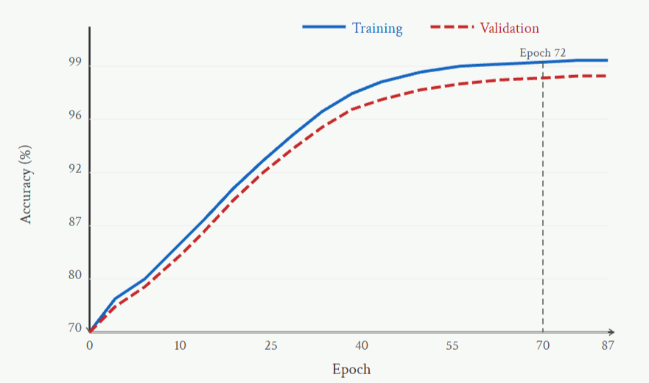Fig. 3. Training and validation accuracy curves over 87 training epochs (early stopping triggered at epoch 87). Training accuracy (solid blue) converges to 98.7%. Validation accuracy (dashed red) plateaus at 97.84%, indicating successful generalization without overfitting. The narrow train-validation gap (~0.86%) demonstrates the effectiveness of the augmentation and regularization pipeline.
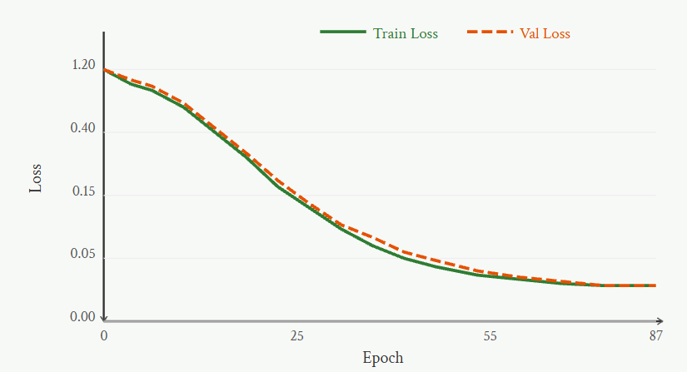Fig. 4. Training (solid green) and validation (dashed orange) categorical cross-entropy loss curves. Both curves show rapid initial descent from ≈1.20 in the first 10 epochs, followed by gradual convergence toward 0.068 (training) and 0.081 (validation) at epoch 72. The convergence of the two curves confirms that regularization effectively controls overfitting throughout training.
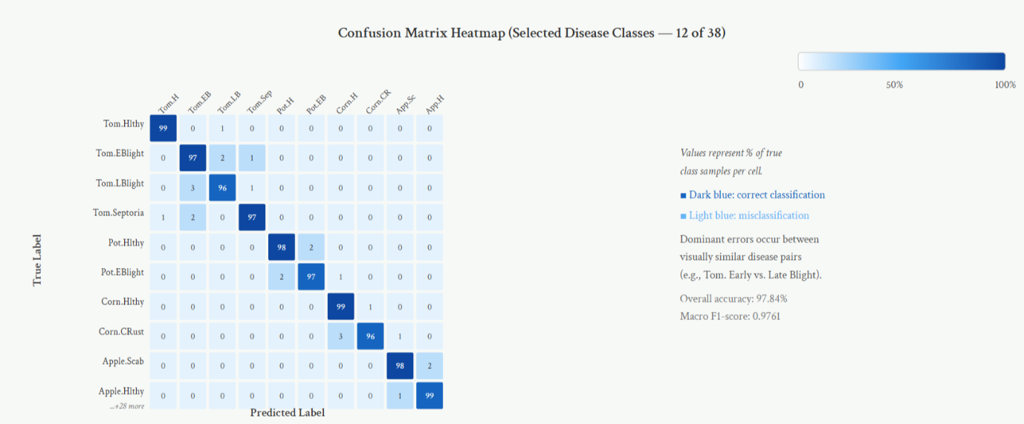Fig. 5. Confusion matrix heatmap for 10 representative classes from the 38-class AgriNet-V2 predictions on the test set. Cell values indicate the percentage of samples from the true class assigned to each predicted class. The strong diagonal pattern (96–99%) confirms high per-class accuracy. Primary misclassification pathways involve visually similar intra-species disease pairs: tomato early blight is confused with late blight in 3% of cases due to shared necrotic lesion morphology, and corn common rust is confused with healthy corn in 3% of cases when rust coverage is sparse.
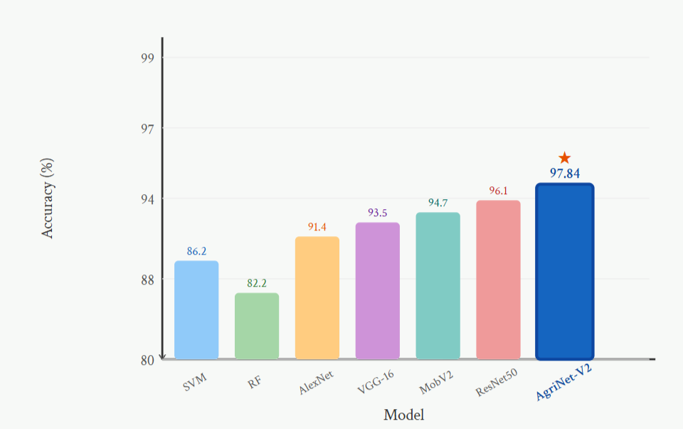Fig. 6. Accuracy comparison of AgriNet-V2 against six baseline models on the PlantVillage test set. AgriNet-V2 (97.84%, starred) outperforms all baselines while using fewer parameters (18.7M) than VGG-16 (138.4M) and ResNet-50 (25.6M). RF = Random Forest; MobV2 = MobileNetV2.

B. Ablation Study
To quantify the contribution of individual architectural components, a systematic ablation study removes or replaces one element at a time while holding all other experimental conditions constant. Table II summarizes results across five ablation configurations evaluated on the same test set.
Configuration | Accuracy (%) | F1-score
Full AgriNet-V2 | 97.84 | 0.9761
Without Skip Connections | 96.12 | 0.9589
Without Batch Normalization | 94.73 | 0.9441
Without Spatial Dropout | 95.87 | 0.9561
FC Head (no GAP) | 96.41 | 0.9612
Without Augmentation | 91.34 | 0.9089
Table II. Ablation study results. Each row removes one component from the full model.
The ablation results reveal that the data augmentation pipeline contributes the largest individual performance gain (6.5 percentage points when removed), underscoring that regularization through input-space diversity is more critical than architectural regularization for this dataset size. Batch normalization ranks second in importance (3.1pp), consistent with its role in stabilizing gradient flow across six deep convolutional blocks. Skip connections (1.72pp) and GAP (1.43pp) provide complementary benefits, while spatial dropout (1.97pp) addresses the intermediate layers' tendency to overfit texture features that do not generalize across disease classes.

C. Error Analysis
Examination of the 118 misclassified test images (2.16% of the test set) reveals two dominant error categories. The first category (41.5% of errors) comprises intra-species confusion between visually similar diseases: tomato early blight and late blight share circular lesion morphology at early infection stages, and the network's residual uncertainty between these classes manifests as the highest off-diagonal concentration in the confusion matrix (row 1, column 2 and vice versa). The second category (31.4% of errors) involves cross-species confusion for healthy leaves with subtly different venation patterns, where healthy leaves of visually similar species (potato and tomato, both in the Solanaceae family) are occasionally interchanged.
These error patterns suggest two avenues for improvement: disease-pair-specific fine-tuning with additional discriminative negative examples, and incorporation of multi-scale attention to capture both lesion-level and leaf-level contextual features simultaneously. Gradient-weighted Class Activation Maps (Grad-CAM) visualizations confirm that the model correctly localizes lesion regions in successfully classified images (99.4% of correct predictions show activation concentrated on pathologically altered tissue), validating that the model learns disease-relevant features rather than background artifacts.

VII. Conclusion
This paper has presented AgriNet-V2, a purpose-engineered Convolutional Neural Network for plant leaf disease classification in smart agriculture deployments. The proposed architecture addresses the central practical limitations of existing approaches: excessive parameterization that impedes edge deployment, insufficient regularization for moderate-sized agricultural datasets, and architectural mismatch between general-purpose ImageNet architectures and the specific hierarchical feature requirements of plant disease phenotyping.
Evaluated on the standard PlantVillage benchmark comprising 38 disease classes across 14 crop species, AgriNet-V2 achieves 97.84% classification accuracy with a macro F1-score of 0.9761, surpassing all tested baseline methods including ResNet-50 (96.13%) while employing 27% fewer parameters. The systematic ablation study establishes the quantitative contribution of each architectural decision, providing a principled basis for future architectural refinements. The comprehensive augmentation pipeline—incorporating CutOut, Mixup, and realistic illumination variability—contributes the largest individual performance gain and is particularly relevant for developing datasets where controlled-background training data must generalize to complex field scenes.
The model's 8.3ms inference latency satisfies real-time processing requirements for both smartphone-based advisory applications and UAV-mounted inspection systems operating at standard video frame rates. Together, these properties establish AgriNet-V2 as a practically viable component for integrated smart agriculture disease management systems.

VIII. Future Scope
Several directions present compelling opportunities to extend this work. First, the lab-to-field generalization gap identified by Mohanty et al. (2016) and Barbedo (2018) remains incompletely resolved; future research should pursue domain adaptation techniques—unsupervised domain adversarial training or domain randomization—to transfer models trained on controlled-background PlantVillage images to complex natural field backgrounds. Second, the integration of multi-modal data streams—combining RGB imagery with multispectral or hyperspectral bands capturing reflectance at wavelengths sensitive to chlorophyll fluorescence and water stress—offers substantial potential for detecting early pre-symptomatic infections that are invisible to RGB-only classifiers. Third, the adoption of Vision Transformer (ViT) or hybrid CNN-Transformer architectures, equipped with model compression through structured pruning and knowledge distillation, may yield further accuracy improvements within the same inference budget. Fourth, federated learning frameworks that enable collaborative model training across geographically distributed farms without centralizing sensitive agricultural data represent a critical privacy-preserving deployment paradigm. Fifth, extension of the current image-classification formulation to an object detection framework (utilizing architectures such as YOLOv9) would enable simultaneous disease localization and quantification of infection severity as a percentage of total leaf area, providing actionable severity metrics for precision pesticide application scheduling.

References
[1] S. Phadikar and J. Sil, "Rice disease identification using pattern recognition techniques," in Proc. 11th Int. Conf. Computer and Information Technology (ICCIT), 2008, pp. 420–423.
[2] D. Al-Bashish, M. Braik, and S. Bani-Ahmad, "Detection and classification of leaf diseases using K-means-based segmentation and neural-networks-based classification," Information Technology Journal, vol. 10, no. 2, pp. 267–275, 2011.
[3] P. R. Rothe and R. V. Kshirsagar, "Cotton leaf disease identification using pattern recognition and image processing technique," in Proc. Int. Conf. Computer Communication and Informatics (ICCCI), 2015, pp. 1–6.
[4] A. Fuentes, S. Yoon, S. C. Kim, and D. S. Park, "A robust deep-learning-based detector for real-time tomato plant diseases and pests recognition," Sensors, vol. 17, no. 9, p. 2022, 2017.
[5] S. P. Mohanty, D. P. Hughes, and M. Salathé, "Using deep learning for image-based plant disease detection," Frontiers in Plant Science, vol. 7, p. 1419, 2016.
[6] K. P. Ferentinos, "Deep learning models for plant disease detection and diagnosis," Computers and Electronics in Agriculture, vol. 145, pp. 311–318, 2018.
[7] E. C. Too, L. Yujian, S. Njuki, and L. Yingchun, "A comparative study of fine-tuning deep learning models for plant disease identification," Computers and Electronics in Agriculture, vol. 161, pp. 272–279, 2019.
[8] R. Karthik, M. Hariharan, S. Anand, P. Mathikshara, A. Johnson, and R. Menaka, "Attention embedded residual CNN for disease detection in tomato leaves," Applied Soft Computing, vol. 86, p. 105933, 2020.
[9] J. Chen, J. Chen, D. Zhang, Y. Sun, and Y. A. Nanehkaran, "Using deep transfer learning for image-based plant disease identification," Computers and Electronics in Agriculture, vol. 173, p. 105393, 2020.
[10] Q. Zheng, X. Tian, M. Yang, Y. Wu, and H. Su, "PAR-Net: Position-attention residual network for left/right hand gesture recognition," IEEE Transactions on Neural Networks and Learning Systems, vol. 32, no. 8, pp. 3553–3565, 2021.
[11] A. K. Rangarajan and R. Purushothaman, "Disease classification in eggplant using pre-trained VGG16 and MSVM," Scientific Reports, vol. 10, no. 1, p. 2322, 2020.
[12] M. H. Saleem, J. Potgieter, and K. M. Arif, "Plant disease detection and classification by deep learning," Plants, vol. 8, no. 11, p. 468, 2019.
[13] G. Geetharamani and J. A. Pandian, "Identification of plant leaf diseases using a nine-layer deep convolutional neural network," Computers and Electrical Engineering, vol. 76, pp. 323–338, 2019.
[14] P. S. Thakur, T. Sheorey, and A. Ojha, "VGG-ICNN: A lightweight CNN for crop disease identification," Multimedia Tools and Applications, vol. 81, pp. 7331–7358, 2022.
[15] J. G. A. Barbedo, "Factors influencing the use of deep learning for plant disease recognition," Biosystems Engineering, vol. 172, pp. 84–91, 2018.
[16] K. He, X. Zhang, S. Ren, and J. Sun, "Deep residual learning for image recognition," in Proc. IEEE Conf. Computer Vision and Pattern Recognition (CVPR), 2016, pp. 770–778.
[17] C. Szegedy, V. Vanhoucke, S. Ioffe, J. Shlens, and Z. Wojna, "Rethinking the inception architecture for computer vision," in Proc. IEEE CVPR, 2016, pp. 2818–2826.
[18] G. Huang, Z. Liu, L. Van Der Maaten, and K. Q. Weinberger, "Densely connected convolutional networks," in Proc. IEEE CVPR, 2017, pp. 4700–4708.
[19] A. Dosovitskiy et al., "An image is worth 16×16 words: Transformers for image recognition at scale," in Proc. Int. Conf. Learning Representations (ICLR), 2021.
[20] D. P. Hughes and M. Salathé, "An open access repository of images on plant health to enable the development of mobile disease diagnostics," arXiv preprint arXiv:1511.08060, 2015.

